|  |
| --- |
| **National University of Computer and Emerging Sciences** |
| Lab Manual 6  “Stored Procedures” |
|  |
| Database Systems |
| Spring 2022 |

Department of Computer Science

FAST-NU, Lahore, Pakistan

Contents

1 Objectives 3

2 Stored Procedures 3

2.1 Benefits of Stored Procedures 3

3 Types of stored procedures: 4

1) Stored Procedures without any parameters: 4

2) Stored Procedures with Parameters: 5

3.1.1 5

1. Single parameters 5

2. Multiple Parameters: 6

3) Stored Procedures with input and output parameters: 6

4 Control Structures in Stored Procedures: 7

4.1 If Else 7

4.2 While 8

5 Variables. 9

References 9

# Objectives

The purpose of this lab is to get started with stored procedures. Why we should the stored procedure? How to create a stored procedure? Input/output parameters, if statement and while in stored procedure and procedure execution.

# Stored Procedures

Stored Procedure in SQL server can be defined as the set of logically group of SQL statement which are grouped to perform a specific task. A stored procedure is a prepared SQL code that you save so that you can reuse the code over and over again.

## Benefits of Stored Procedures

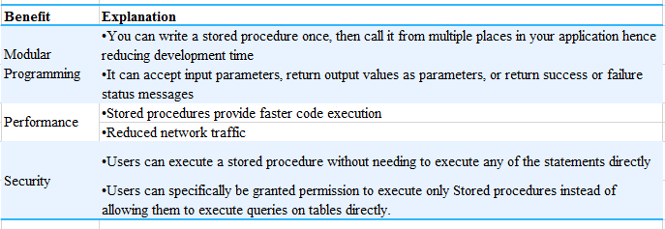

Every time you execute and SQL statements syntax Check, Compilation and done before Execution and Return data.

However, Syntax check and Compilation is done while creating a procedure, and not on every execution which makes in faster than simple SQL statements.

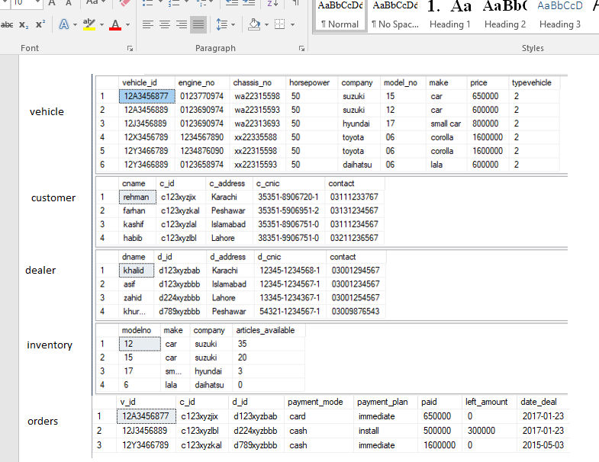

Let us consider the above schema and make some stored procedures on the given schema.

# Types of stored procedures:

Stored procedures can be characterized on the basis of the types of arguments that can be sent to them. Stored procedures are quiet similar to the functions and methods that are used in C++ and other languages.

Before moving to the types of stored procedures let us first look at the general syntax of the stored procedures

Crete procedure <procedure name> @variable datatype, @variable2 datatype……

As begin

The code for your program

end

## Stored Procedures without any parameters:

The syntax for the stored procedures is as follows:

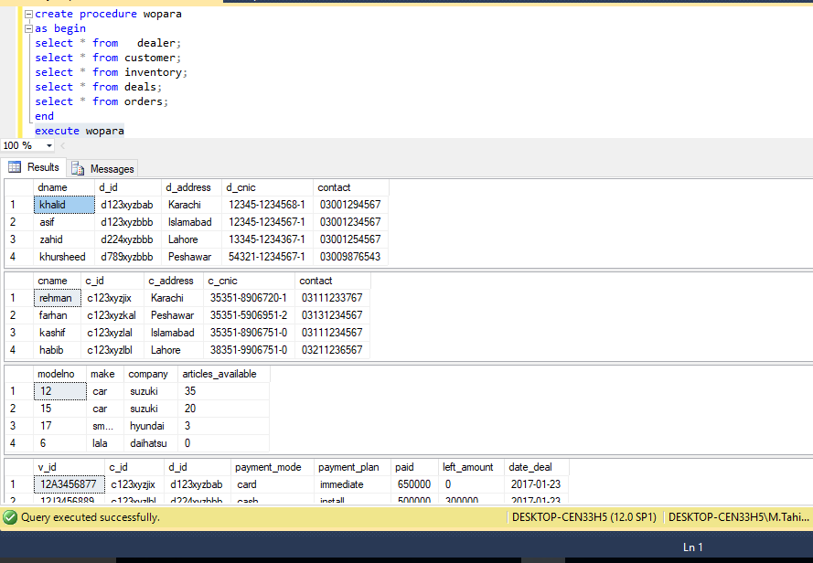

## Stored Procedures with Parameters:

However if we want to send some parameters in case we want to manipulate the database according to some special values or some other certain feature we use this type of stored procedures. Let us look at the syntax for this.

### 

### Single parameters

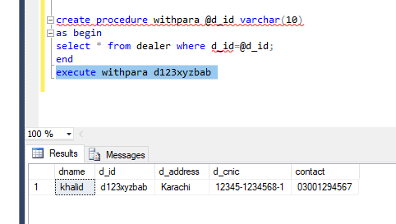

### Multiple Parameters:

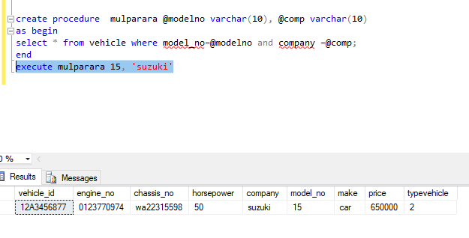

## Stored Procedures with input and output parameters:

Till now we have seen only the input parameters now we shall see output parameters as well

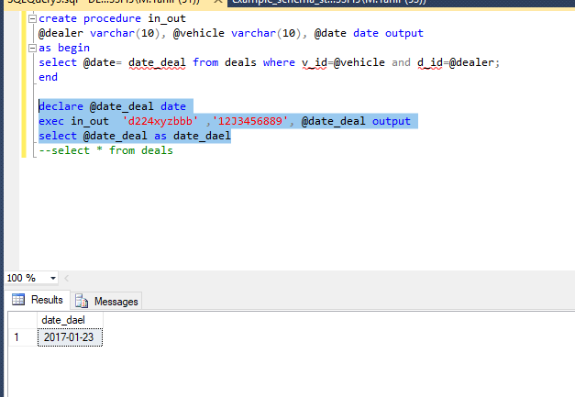

# Control Structures in Stored Procedures:

## If Else

Like functions in other languages stored procedures also provide the liberty of using control structures.

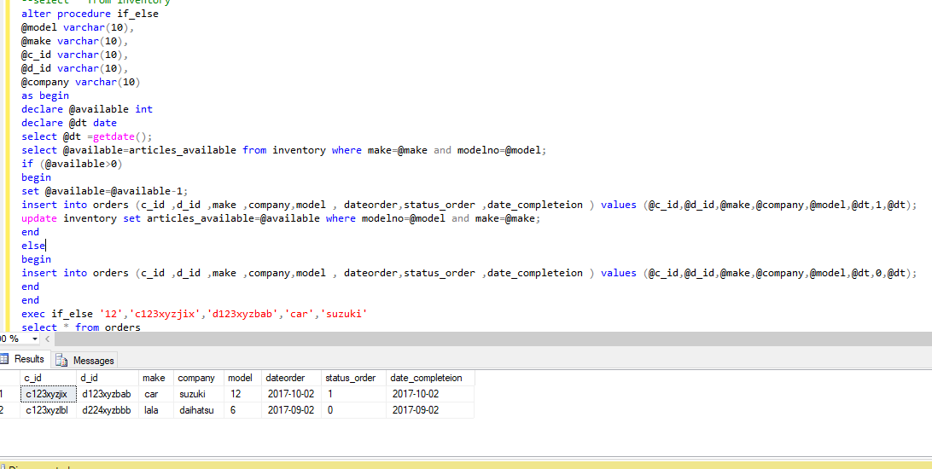

In this example it can be easily seen that we can do anything we want in a stored procedure.

## While

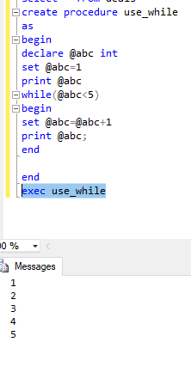

This is a very simple example while loops are used rarely in real world scenarios but you must have a little know how about it.

# Variables.

Like in any other programing language SQL also provides scalar variables, which are very useful when creating stored procedures. We have seen almost all of these in the examples given earlier

However let us take a closer look:

* Variable in SQL start with @ symbol
* Variable is declared using DECLARE keyword as follow
  + *DECLARE @variableName datatype;*

Or to declare multiple variables in one statement.

* + *DECLARE @variable1Name Datatype,@variable2Name  datatype;*
* Variable can be assigned a constant scalar value as follow
  + *SET  @ variableName  = value;*

Or To assign values to multiple variables in one statement

* + *select @ variable1Name   = value, @variable2Name  =value;*
* Variable can be assigned a scalar value thought SQL statement as well
  + *SELECT @vairableName = columnName FROM Table WHERE  <condition>*

If SQL query returns more than one row, 1st value will be assigned to variable

* You can retrieve the value of variable as follow
  + *Select @variableName*
* You can perform operations on variables like addition, concatenation, substring etc

# References

* Chapter 5 Lesson 1 and Lesson 4, MCTS 70-433 SQLServer 2008 Database Development.
* Chapter 5 Elmasri